## horizontal line



Lend Indeed

Jatinderpal Singh (1896383)

Sahil Sachdeva(1896477)

Jatinder Singh Mann(1896568)

Arshpreet Kaur Sidhu(1894834)

Gagandeep Kaur(1896910)

MAD-314

|  |
| --- |
| **Table of Contents** |

1.Introduction………………………………………………………………………………………………………………..…………………..2

2.Project Description………………………………………………………………………………………………………………………….3

2.1. Planned Sprint Timeline...............................................................................................................3

3. Requirements ................................................................................................................................................4

3.1. Functional Requirements: ...........................................................................................................4

3.2. Non-functional Requirements: ...................................................................................................5 4. UI Mock-Ups ................................................................................................................................................20

|  |
| --- |
| **Introduction** |

## 1.Introduction

The purpose of this project is to create an Android Mobile Application which will help the students (who will be the user of our application) to borrow the items such as Books, Computers, laptops, etc. Students and Admin will be the primary users of our application.

Admin and Students both have their own login access and both have their own different dashboards and features. The purpose of this documentation is to define the overall project specification as well as the general direction of the prototype development. In this case, the targeted readers of the document are the stakeholders, who are interested in the utilization of the application as well as the developers that will be creating the application.

|  |
| --- |
| **PROJECT DESCRIPTION** |

## 2.Project Description

The Lend System Application is built to let the student find the items and borrow it according to their desire. The application is being developed on Android Studio using java language. Xml files are also used just to design for application. For connectivity, we will use a firebase database to store the information and data into it.

Throughout the application development, we will use Scrum Agile and also use Github. We will divide into four sprints and the time period of each sprint will be two weeks. After two weeks, we will present the progress to our coordinator and get feedback from them.

## 2.1 Planned Sprint Timeline

|  |  |  |
| --- | --- | --- |
| Sprints | Start Date | End Date |
| 1 | 05-05-2020 | 24-05-2020 |
| 2 | 25-05-2020 | 07-06-2020 |
| 3 | 08-06-2020 | 28-06-2020 |
| 4 | 29-06-2020 | 14-07-2020 |

|  |
| --- |
| **Requirements** |

## 3. Requirements

## 3.1. Functional Requirements:

|  |  |  |
| --- | --- | --- |
| **ID** | **Description** | **Comments** |
| F01 | The application will have a Splash screen. | To show the logo. |
| F02 | The application will have a Login screen and Sign-up page for students and only login page  For admin | To access the account for application and password must be greater than 8. |
| F03 | The application will have a page where users can see their information like student id, total no of items, no of borrowed items, favorite. | To display information of students. |
| F04 | The application will have a page to recover their password in case of forgetting the password. | To secure the account for users and admin. |
| F05 | The user will get the notification like when will the items again be available if the item will be borrowed by someone but not see the name of the borrowed person. | To get updated with an application. |
| F06 | The student will also search for a particular item by filters like date, type, and request admin for a particular item. | A list of items will be displayed and filter out items. |
| F07 | The application will have a page where the admin can manage all the data like a list of items and borrowed items and a list of students etc. | Allow them to manage and save data in files. |
| F08 | The application will show the deadline of borrowed items in the student profile as well as administration data record. | Allow returning items before deadlines. |

## 3.2 Non-functional Requirements:

|  |  |  |
| --- | --- | --- |
| **ID** | **Description** | **Comment** |
| NFR-01 | The user and admin confirm the email address to protect data from unauthorized users. | Other Operating System not covered |
| NFR-02 | The users will have their own Android Operating System. | Other operating must will not work |
| NFR-03 | Internet connection is must before accessing application. | To avoid unnecessary charges |
| NFR-04 | The system will able to logout automatically when the user or admin is no longer using an app. | For security |
| NFR-05 | The system will be accessible by all the registered members. | Accessibility |

|  |
| --- |
| **MOCKUPS** |

## 7. Mockups

## 

## SPLASH PAGE

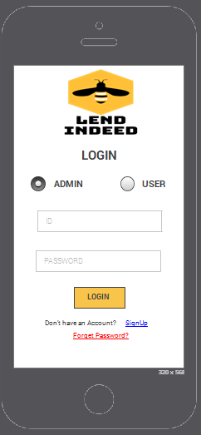

## LOGIN PAGE

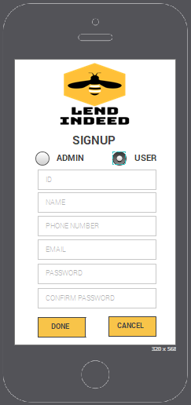

## SIGNUP PAGE

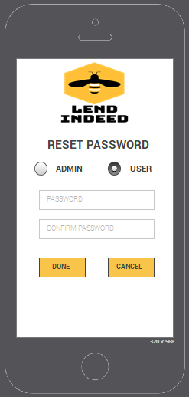

## RESET PASSWORD PAGE

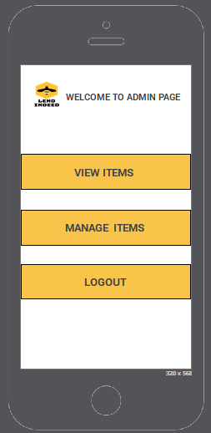

## ADMIN PAGE

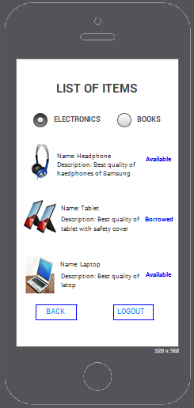

## ADMIN CAN VIEW ITEMS

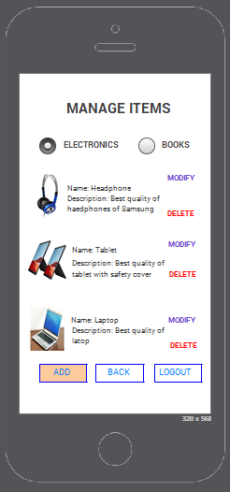

## ADMIN CAN MANAGE ITEMS

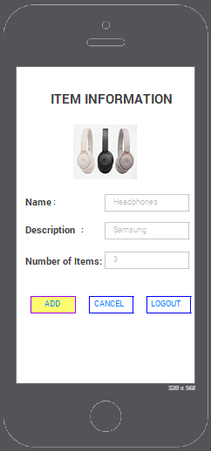

## ADMIN CAN ADD ITEMS

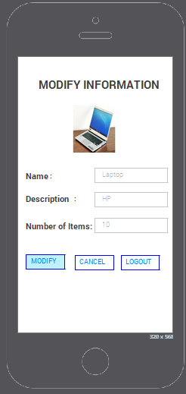

## ADMIN CAN MODIFY ITEM

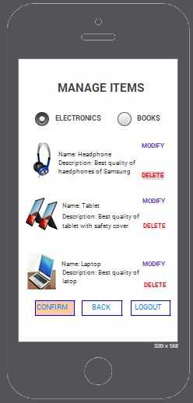

## ADMIN CAN DELETE ITEM

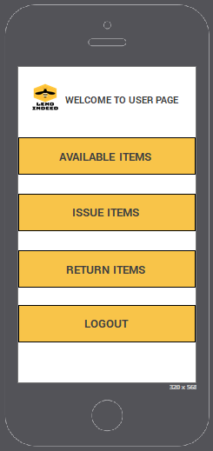

## USER PAGE

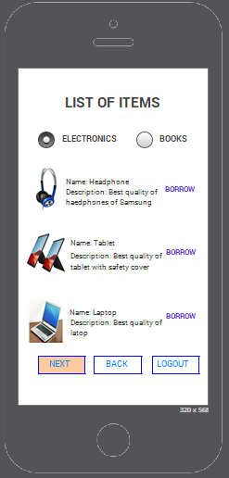

## USER CAN SEE AVAILABLE ITEMS

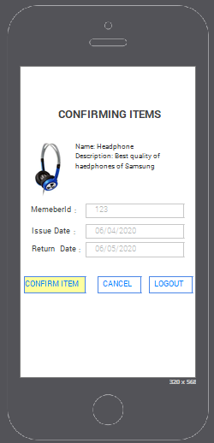

## USER CONFIRMING ITEMS

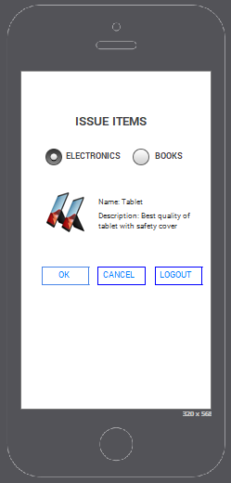

## USER CAN SEE ISSUED ITEM

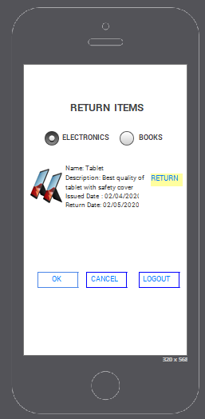

## USER CAN RETURN ITEMS

## 